Reflection Document:

My final work is intended to convey an experience that is both liberating through the act of flight, and on a user experience level, is intuitive for a player and fun. During the build of the final interactive work, the only participant around was my sister, who is 21.

During the initial testing, I had a mock up of a very basic object with Kinect controls, and asked my sister to try fly with the object. The trickiest part was getting her into the right space and facing the right direction for the Kinect to recognize her. I’ll admit that my room is not the ideal space for the work, being a cramped space, but it reinforced the need for clear signage for if the work were ever set up in an exhibition space.

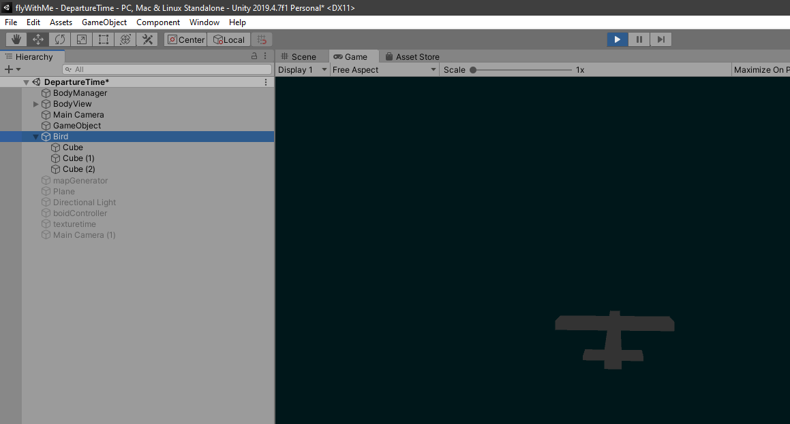

Initial Kinect Controls Implemented.

Another issue is that I had told her she was controlling a bird, which led to her trying to fly as such. At this point I just wanted her to outstretch her hands, rather than to furiously flap her arms in hopes of getting some sort of feedback on screen. This led to the work featuring a plane, as this issue probably wouldn’t be avoided, and I wasn’t planning on making a full-on flapping algorithm.

In terms of interacting with the final work. Overall the experience seemed like a fun one. Being already familiar with the controls, my participant was quickly gliding around the terrain looking for something to do within the simulation. The planes were introduced, (perhaps too quickly) and she immediately went in chase of them. I feel as if the pace of the work was a little fast and is in need of some fine tuning, but the overall controls seem to work on a technical level.

With some level of an idea how an audience would interact with the work, I feel as the interaction scenarios would pan out as such.

Scenario One: No users

The plane will head in a straight line through the simulation. As it does not adhere to the flocking algorithm, the planes won’t form a tight pack, and as such, the work can be left for a lengthy period of time with no interaction. The work will simply fly over the limitless generative landscape.

# Scenario Two: Single User

A user enters the arbitrarily mapped out area that is scanned by the Kinect. As a person becomes tracked by the Kinect, a graphic pops up that hints at how the user is to outstretch their arms. This instruction can also possibly be explicitly stated outside the space, but I like the idea of the audience having to do some level of investigation themselves. Once they figure out the controls work, they start to explore the space and find planes to play with.

# Scenario Three: Multiple Users

At this stage, only one plane can be controlled, and the controls will be given to the first person it tracks. So a new member entering the space cannot hijack controls until the first member leaves the space. This scenario has room to be expanded, and in future iterations, I would like a scenario that each new person is assigned to a new plane. Since not all planes are within view of the main camera, one possibility is that a new plane can be spawned on screen, simply is not tracked by the camera, and constrained to stay within the visible space. Another scenario is that control can be assumed over an AI plane, and a new camera is placed over the plane. This scenario involves partitioning the screen into sections, one for each tracked plane. This however feels like too much of a game-ification.

# Summary

My work intended to be a simulation of the natural, and whilst a generative landscape is created, overall that element of the work does not feel as emphasized as it should. The work mainly feels to be about the planes. This is mainly since there is little interaction over the landscape itself, and the fact that besides the planes, the landscape feels empty and repetitive, despite its generative nature. However, despite this, I am still happy with how the final work looks and feels. It seems like a playful experiment that immerses its participants and perhaps on some level, critiques our ignorant attitude to the reality of militaristic crimes through the use of Drone attacks.